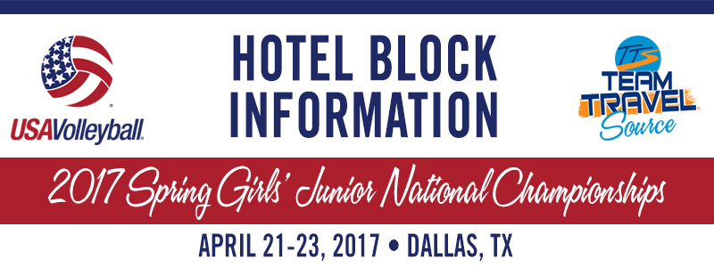

Elite VBTC 18 Black
Booking link: https://aws.passkey.com/go/e5648730
Hotel: Aloft Dallas Hotels- 13 rooms blocked
Arrival and Departure Dates: April 20- April 23
USAV Team Code: FJ8EVBTC1OV
*The USAV Team Code must be on each reservation to ensure stay-to-play compliancy.

Expiration Date: The block will expire on February 5, 2017. On this date, any unused rooms will be placed back into general inventory or assigned to teams on a wait list for that particular hotel.
Booking Instructions:
1. Click on your team’s unique booking link.
2. Choose your check in and check out date.
3. Select the room type that you wish to book.
4. Complete the personal contact information and payment information. A credit card is required to make a reservation. However, no payment is due when the reservation is made. You will pay for your room upon arrival at the hotel. Please make sure to refer to your specific hotel's cancellation policy for those details as well.
5. You will receive a confirmation email immediately following completion of the reservation with an Acknowledgement Number.
6. You may make changes & cancellations within this same link using your Passkey Acknowledgement Number.

CANCELLATION FEE FOR RESERVATIONS CANCELLED AFTER MARCH 1, 2017 -
In an effort to provide the best available options to all attendees and to ultimately secure as many people in the hotel of their choice, a $40.00 non-refundable cancellation fee will be charged to the credit card on file for all reservations made for the 2017 USAV Spring Girls’ Junior National Championship that are cancelled after March 1, 2017. This policy has been implemented to discourage individuals from holding multiple reservations at multiple properties and then cancelling the reservations at the last minute. Holding unnecessary rooms that are often in high demand does not allow others the ability to book these rooms. The cancellation fee will encourage attendees to make their official hotel selection prior to March 1, 2017. Team Travel Source will charge the $40.00 non-refundable cancellation fee for any reservation cancelled after March 1, 2017. Please note that this fee is separate from and in addition to any cancellation charges that you may incur from the hotel (please refer to your specific hotel’s cancellation policy for accurate details). This charge is applicable only to full cancellations, and not to adjusted arrival and departure dates. Team Travel Source appreciates your understanding as we work to accommodate as many people as possible in the hotel of their choice. If you need to modify or cancel your reservation, you can do so online via the reservation site or contact Team Travel Source at 502-354-9103. Office hours are M-F 9:00 AM to 5:00 PM EST.

Please let me know if you have any questions regarding your team’s group block! I can be reached at 844-875-4586 or dana@teamtravelsource.com.

