Northeast Qualifier (March 18-20, 2016)
Philadelphia, PA
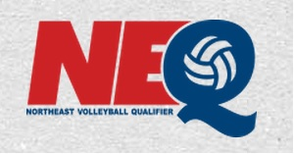
- $165/night (Double/Double)
Sheraton Philadelphia University City
3549 Chestnut Street
Philadelphia, PA 19104
Reservation Number: 70191

2.2 Miles from the convention Center
$25 Self-Park Fee
No Free Breakfast Included
Rail system by hotel travels right to Convention Center
11 Rooms Available

Instructions for Adding Rooming Lists:

- Go to https://www.advancedeventsystems.com/Hotel/UpdateReservation.aspx
- Enter the e-mail address of the person who made the reservation: elitevbtc@integritygym.com
- Type in above number under desired hotel as the Reservation # 70191
- A summary of your reservation will appear.
- From this page, identify the room type you would like to add your rooming list to. Be sure to check the check in and check out dates.
- Please select an available room from the reservation drop down.
You will need to type one person per row. Please make this as accurate as possible for check in and security purposes.
- Do not choose the box marked, “Fill Room Contact with Main Contact’s Info” You will need to enter all your contact info and credit card info for your family.
- Type in your credit card information.
No one has access to your credit card information except for the hotel. AES web site is secure using SSL (Secure Socket Layer) encryption.
- Click update.
- If you have any problems, please call 800-476-0060 ext 118 or Email: wheels@capitolsportscenter.com
Kristi Reynolds, Doug Hasting, Eddie George, Kathy McNabb please contact me directly because your rooms are currently reserved under Elite’s credit card.

Deadline 11/5/15

