Big South (Atlanta, Georgia March 3 – April 2, 2017) www.bigsouth.us
Sheraton Atlanta Hotel
165 Courtland St. NE
Atlanta, GA 30303

Hotel is walking distance to the venue.

Three Room Types
1. One King Bed Rooms $130/night
2. Two Queen/Full Beds Rooms $130/night
3. One King Bed Rooms with breakfast included for up to 2 people $168/night

Parent Passcode: (If your team’s P-Code has all the rooms filled, just pick another team’s P-Code)
13Black: P11500167924280 $168 King w/ Breakfast (make sure to add at least 2 name to rooming list for breakfast)
13 Blue: P12500167924290 $168 King w/ Breakfast (make sure to add at least 2 name to rooming list for breakfast)
14Black: P13500167925200 $168 King w/ Breakfast (make sure to add at least 2 name to rooming list for breakfast)
14Blue: P14500167925210 $168 King w/ Breakfast (make sure to add at least 2 name to rooming list for breakfast)
15 Black: P18510145722250 $130 Choice of King or 2 Doubles
15 Blue: P19510145722260 $130 Choice of King or 2 Doubles
16 Black: P16510145722230 $130 Choice of King or 2 Doubles
16 Blue: P17510145722240 $130 Choice of King or 2 Doubles
17 Black: P14510145722210 $130 Choice of King or 2 Doubles
17 Blue: P15510145722220 $130 Choice of King or 2 Doubles
**Your credit card will be processed for one room night on 1/30/17
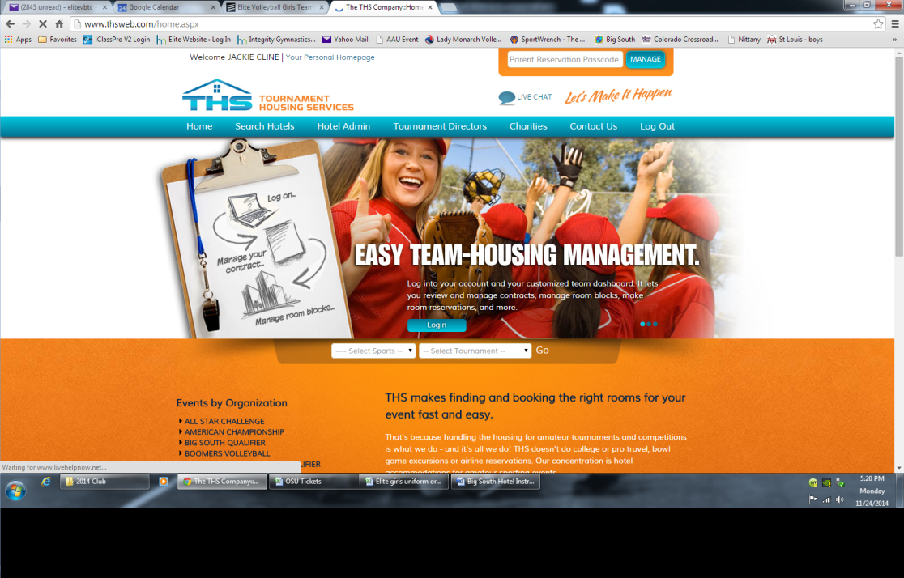

1.) Enter one of the P-Codes from above into the Parent Passcode Box.
2.) Enter your information and click on the “Add” button on the left hand side of the cell.

3.) A confirmation email will be sent to the email address they enter. Note: It does take a few minutes to receive.

If you do not receive a confirmation email or prefer to make reservations over the phone have them call our reservations department at (888) 536-8326, and make sure they reference that long P-number. That way we’ll be able to place them into your team’s block. Deadline: 12/1/2016

